**NG'ENO KEVIN KIPYEGON**

1. **SAMPLE OF WORK PORTFOLIO**

  

**+254 719 471 625**

**ngenokevin**

**kngeno.kevin@gmail.com**

**Mobile Data Collection Apps**

* **Somalia Flood Monitoring Tool (2021): FAO Somalia**

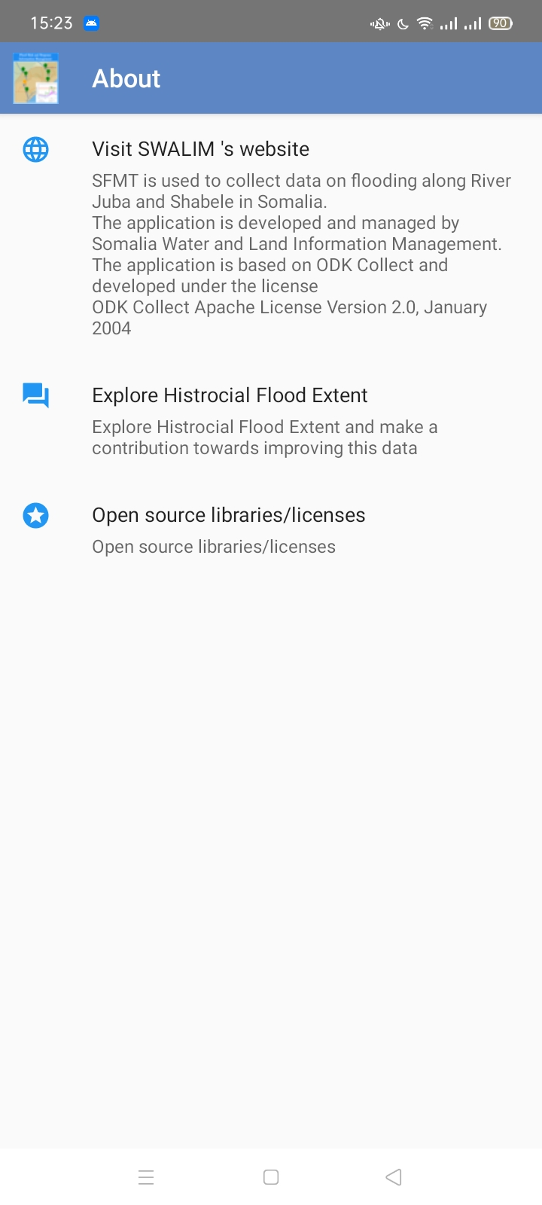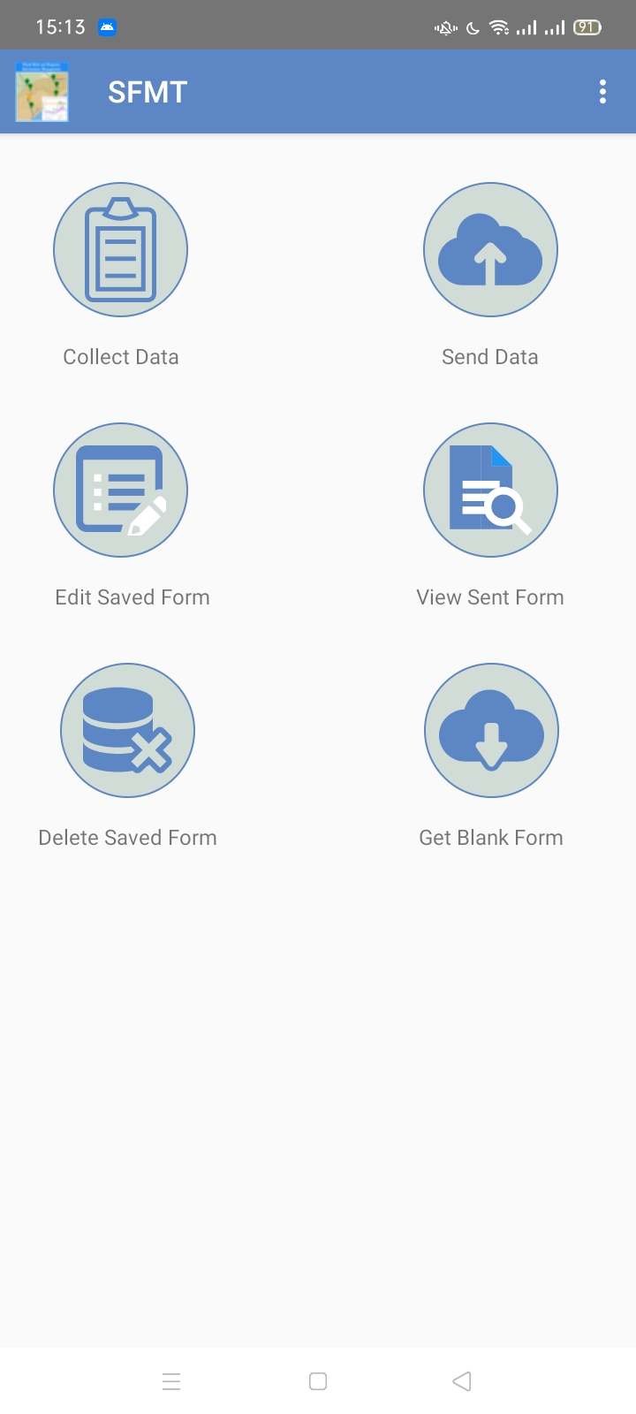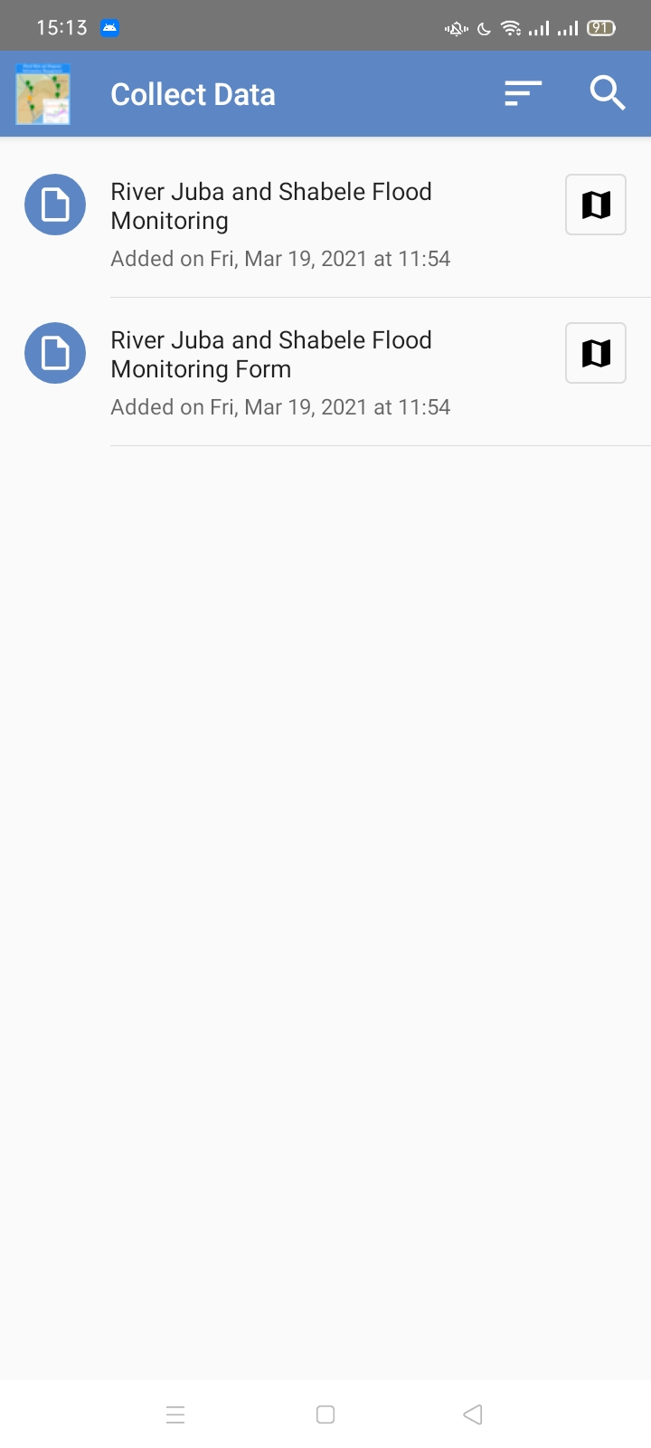

**Description:** A mobile application developed using ODK framework to collect flood monitoring data for River Juba and Shabbelle in Somalia in order to aggregate data on areas where floods have occurred for proper response strategies. Visualized on a webGIS application link below.

**Responsibilities:** Design and development of the mobile data collection app to a centralized portal for aggregation and visualization.

**Skills:** ODK, ODK Aggregate, GeoServer, QGIS and PostgreSQL- PostGIS

* **WaSHMIS Collect (2016 – 2018) : Upande, Kenya**

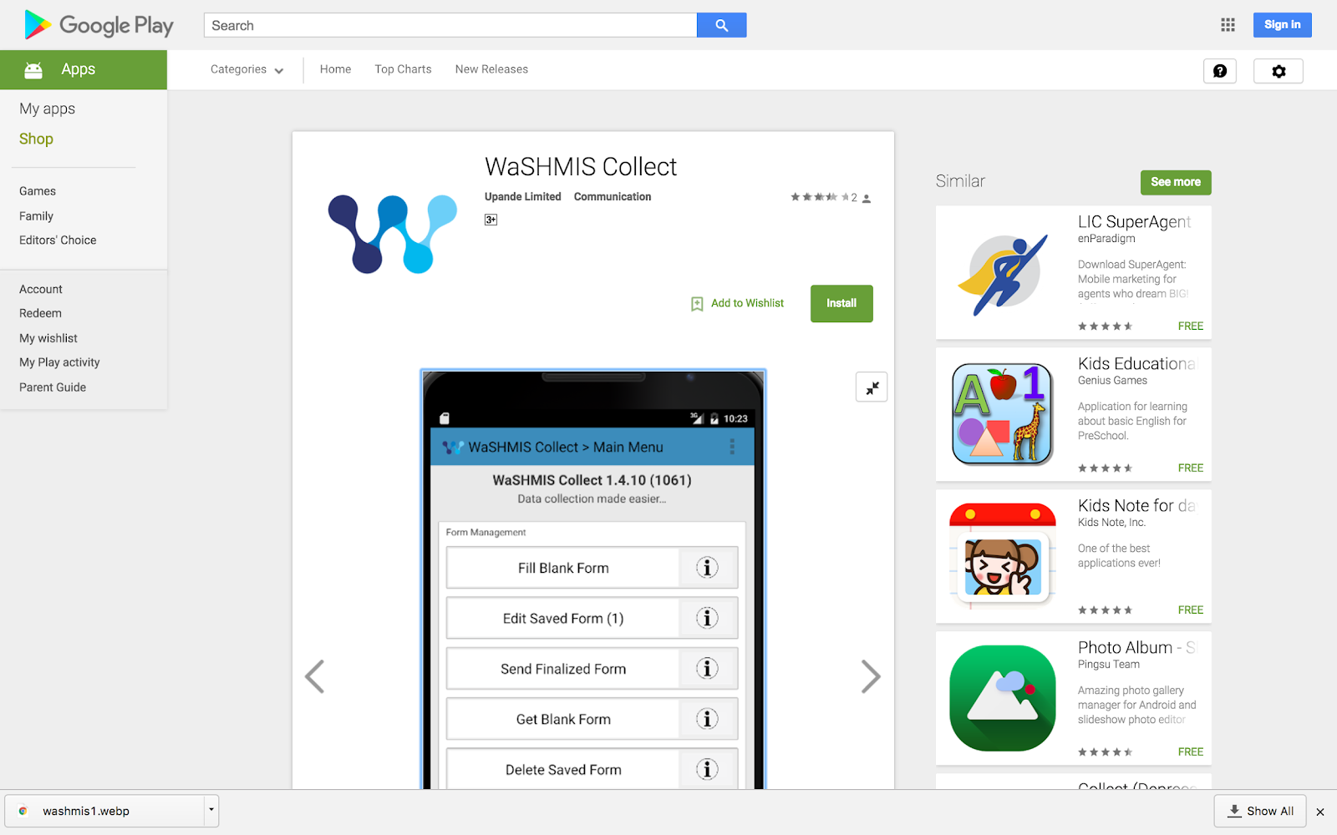

**Description:** A mobile application developed using ODK framework to collect Customer Identification Survey information or any other data for Water Service Providers.

**Responsibilities:** Design and development of the mobile data collection to collect line features and transmit to a centralized portal for aggregation and visualization.

**Skills:** ODK, ODK Aggregate, GeoServer, QGIS and PostgreSQL- PostGIS, GeoNode

**WebGIS Applications**

* **Uganda National Drought Monitoring Tool (CDI) (February - April 2025)**

**Landing Page**

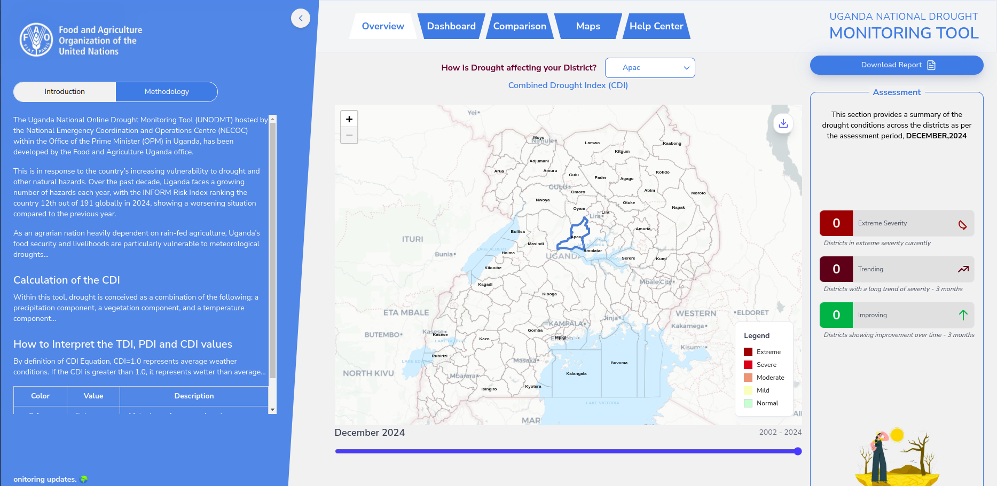

**Combined Drought Index**

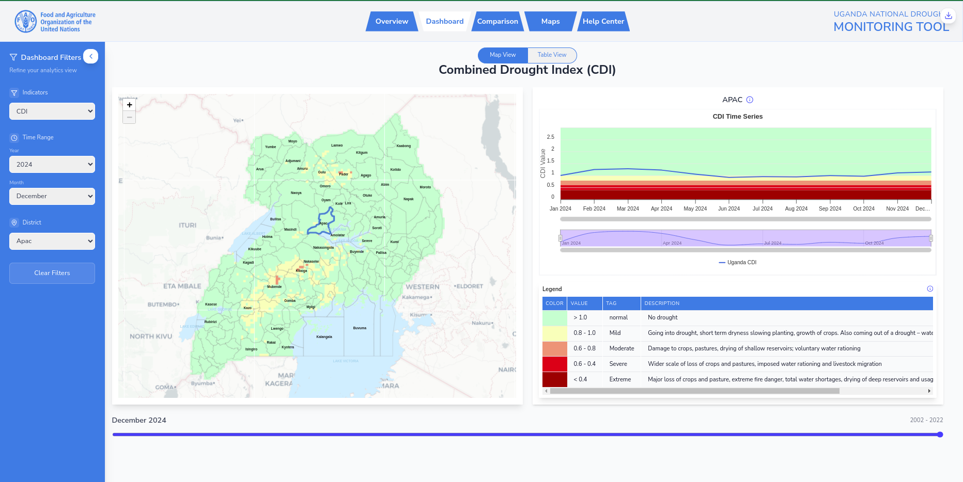**Description:** This is in response to the Uganda’s increasing vulnerability to drought and other natural hazards. Over the past decade, Uganda faces a growing number of hazards each year, with the INFORM Risk Index ranking the country 12th out of 191 globally in 2024, showing a worsening situation compared to the previous year.

**Data:** Precipitaion using CHIRPS, Temperature using MODIS LST, NDVI using MODIS and VIIRS. Administrative boundaries from UN OCHA.

**Responsibilities:** GIS workflow integration, Satellite imagery processing, Cartography, APIs, Backend system and Geoprocessing.

**Skills:** React, Python (GeoDjango), Rasterio, GeoPandas, Numpy, GeoServer, Leaflet Js, Bootstrap, QGIS, uDig, PostgreSQL-PostGIS, Google Earth Engine and Digital Ocean

**Domain; https://cdi-frontend-olive.vercel.app/**

* **Early Warning and Anticipatory Action System (EWAAS) (July 2023 – December 2024) Under Active Development: Eastern Africa**

**Landing Page**

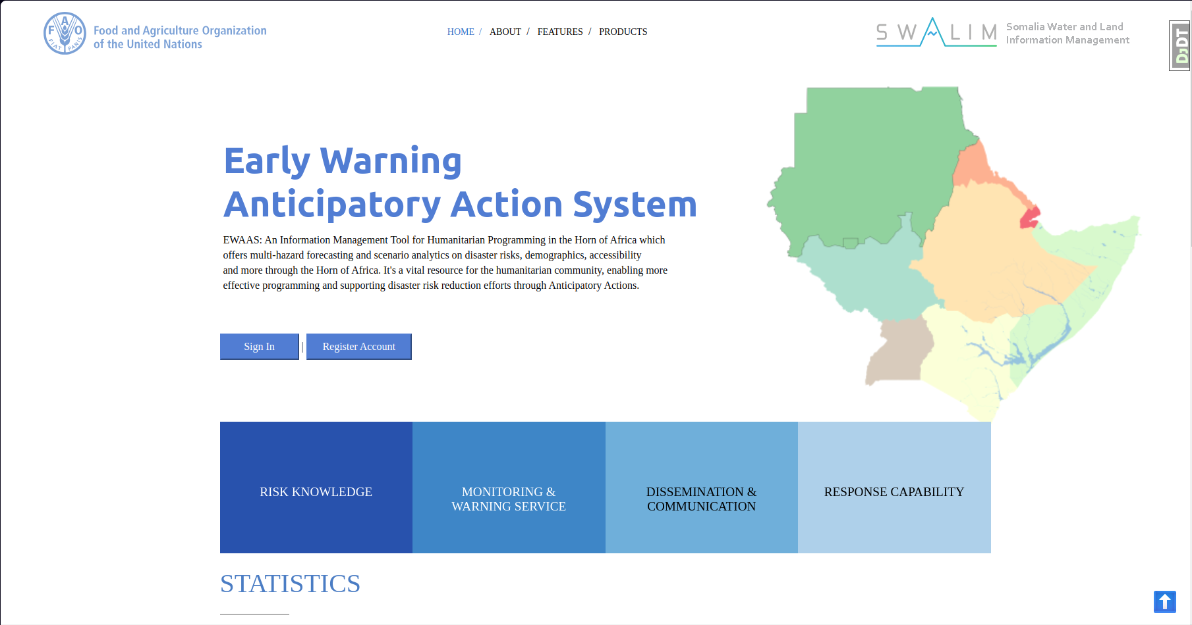

**Scenario Dashboard for Gode Town**

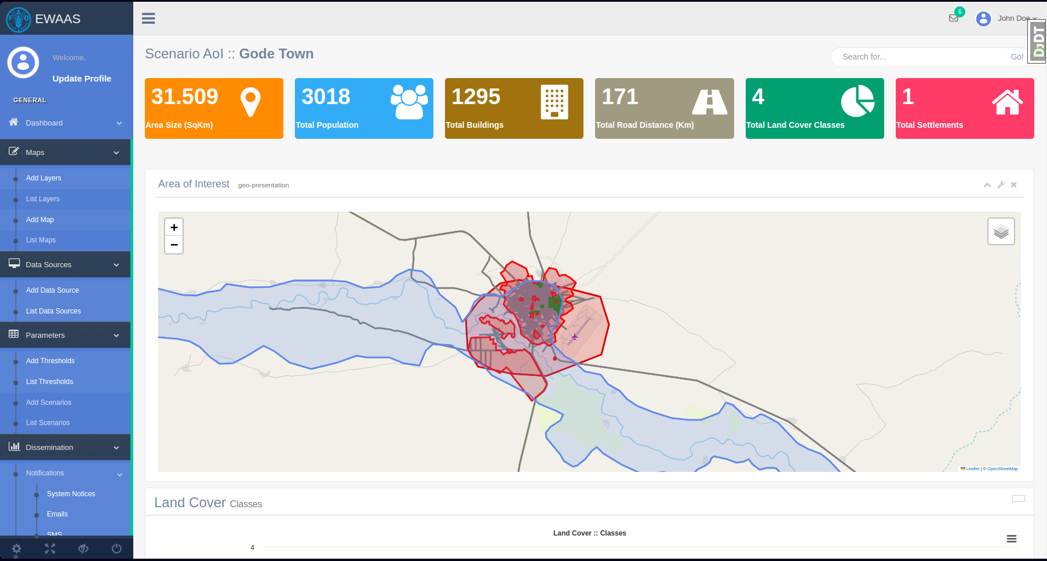**Description:** Early Warning and Anticipatory Action System is an Information Management Tool for Humanitarian Programming in the Horn of Africa which  
offers multi-hazard forecasting and scenario analytics on disaster risks, demographics, accessibility and more through the Horn of Africa. It's a vital resource for the humanitarian community, enabling more effective programming and supporting disaster risk reduction efforts through Anticipatory Actions.

**Data:** Satellite Imageries Sentinel2 for Land Use Land Cover, World Population, GloFAS for potential area of interest (NetCDF) and Open Street Map datasets from Mapathons.

**Responsibilities:** GIS workflow integration, satellite imagery processing and cartography and system development.

**Skills:** OSM, Python, Leaflet Js, Bootstrap, ArcGIS Pro ModelBuilder, uDig, PostgreSQL-PostGIS, AWS and Digital Ocean

* **Mara Rangeland Information System (MARIS) (2017 - 2023): ITC - Netherlands & Upande, Kenya**

**Biomass Production**

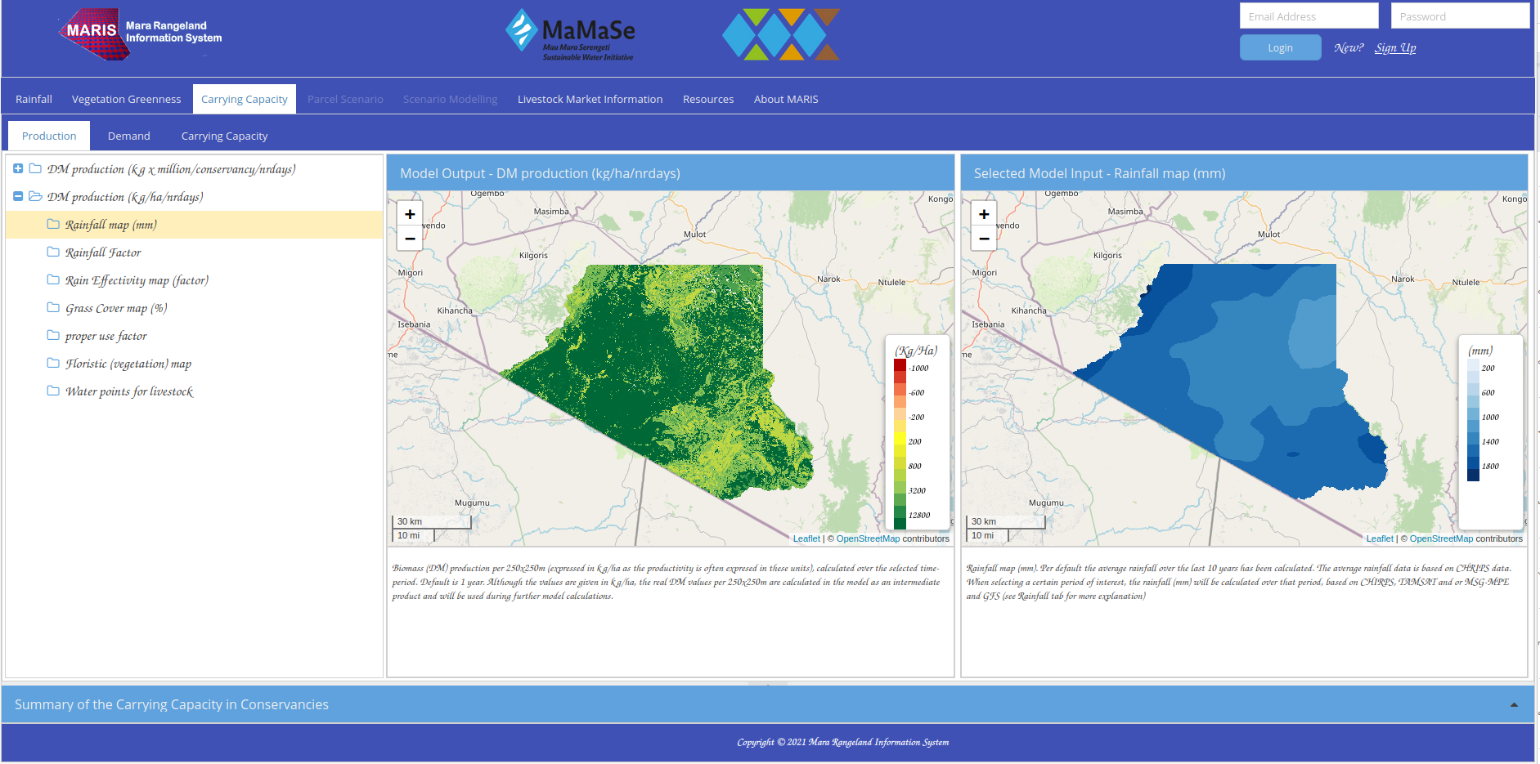

**Rainfall Forecasting**

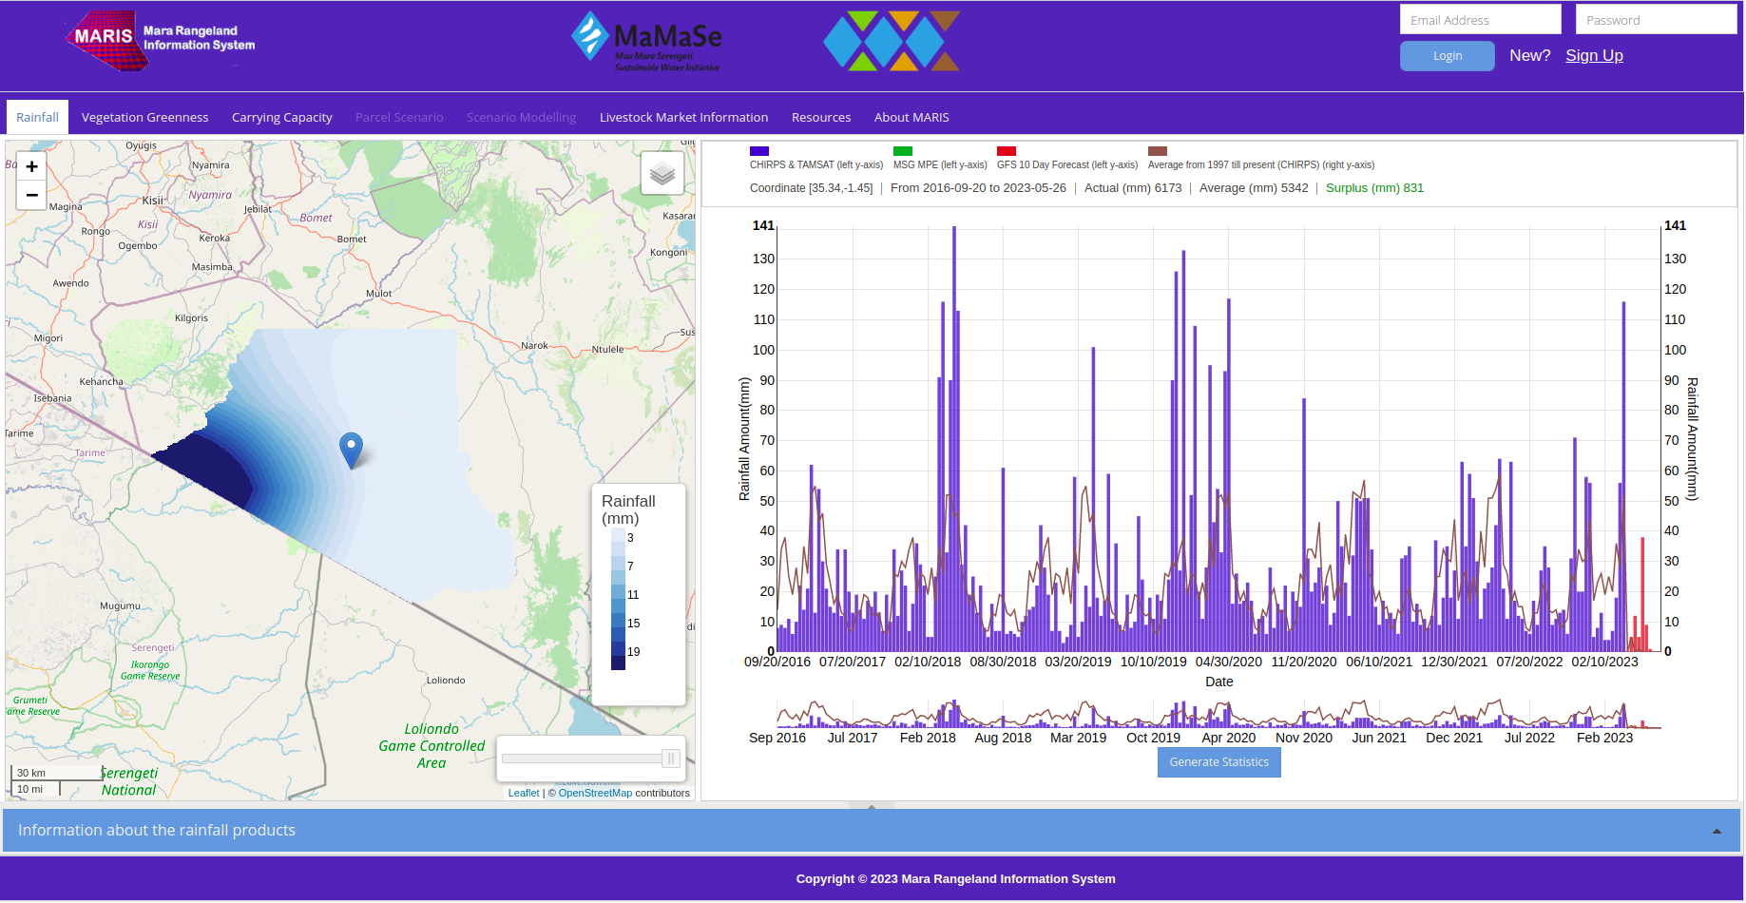**Description:** Mara Rangeland Information System developed to monitor grasslands and find sustainable and resilient livelihood scenarios in pastoral grasslands, where applicable in the near presence of wildlife, respecting the carrying capacity of the ecosystem with awareness of the market opportunities and threats as well as other information to manage pastoral grasslands.

**Data:** Satellite Imageries CHIRPS & TAMSAT for rainfall monitoring, Multi-Sensor Precipitation Estimate (MPE) and MD GFS 10 Day Precipitation Forecast for rainfall forecating and LandSat for NDVI. Data Modelling using ILWIS.

**Responsibilities:** Data modelling, GIS workflow integration, satellite imagery processing and cartography.

**Skills:** ODK, ODK Aggregate, Angular, Material Design, Php7, Python, ArcGIS Pro ModelBuilder, ILWIS, uDig and PostgreSQL-PostGIS, Amazon Web Services

**Domain; https://mara.rangelands.itc.utwente.nl/**

* **Land Resource Management Information System (2022): FAO Somalia**

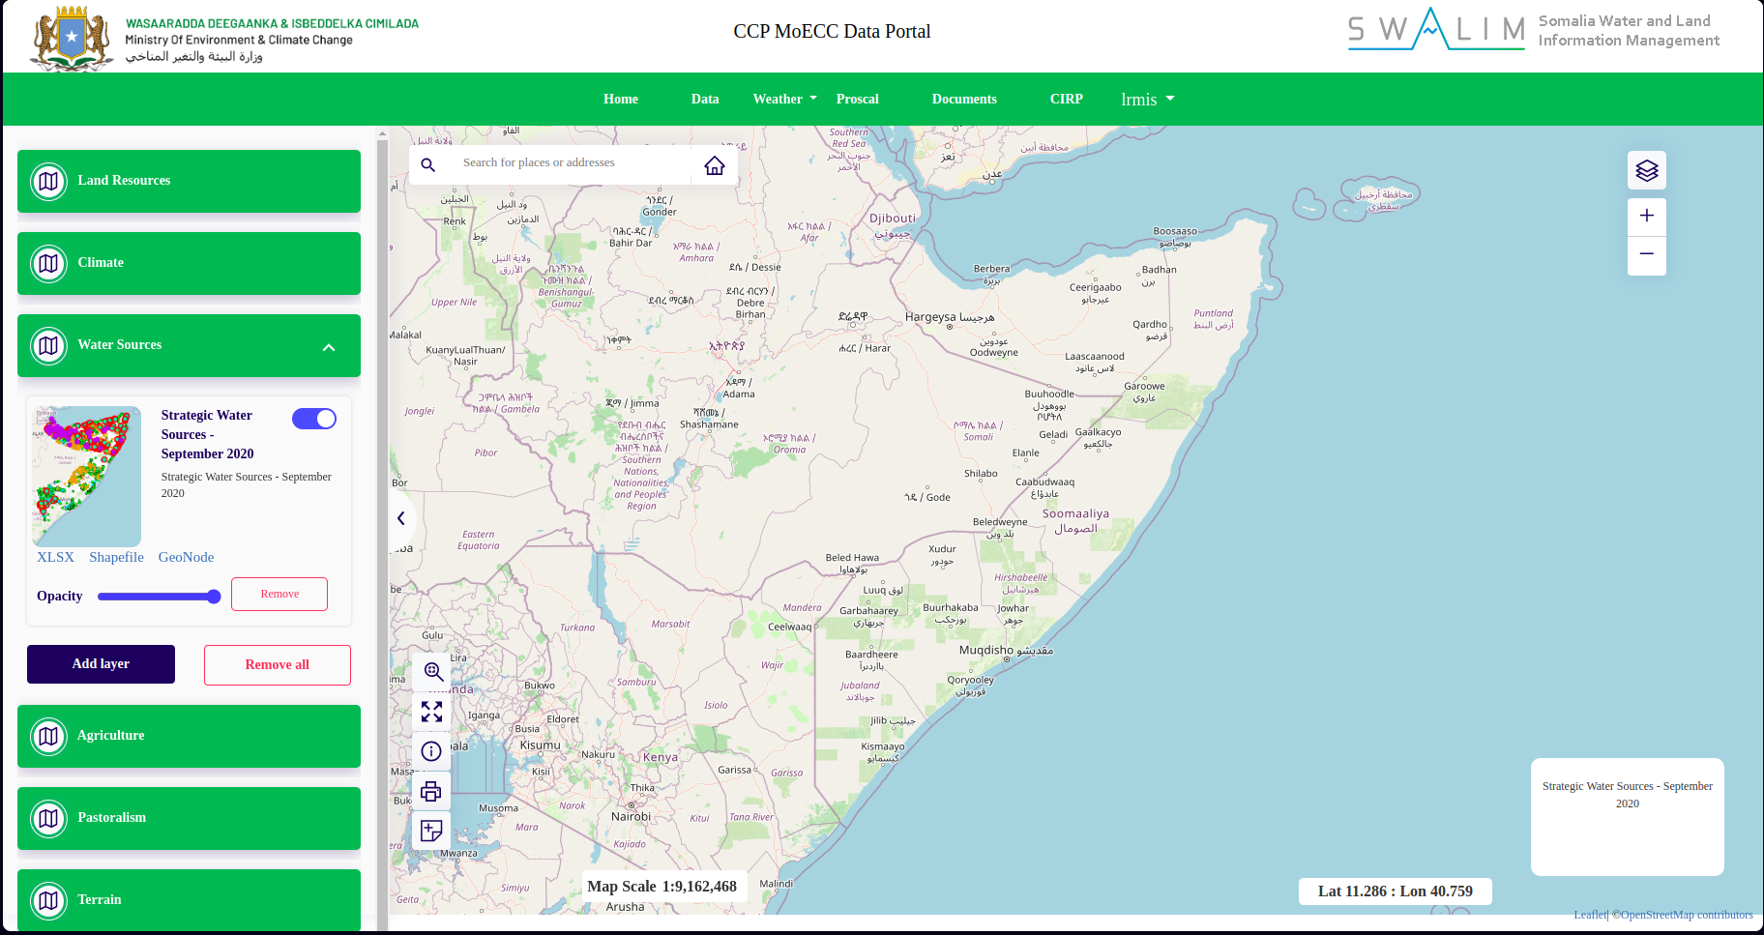**Description:** A WebGIS app to provide access to GIS data and organize the flow of information (standardized data formats with adequate metadata) on land resources and agricultural information amongst stakeholders.

**Responsibilities:** Primary Developer

**Skills:** Python, Django, Boostrap4, Leaflet, GeoServer, Google Earth Engine, ArcGIS Pro and PostgreSQL- PostGIS

* **Drought Monitoring Tool for Somalia (CDI) (2021): FAO Somalia**

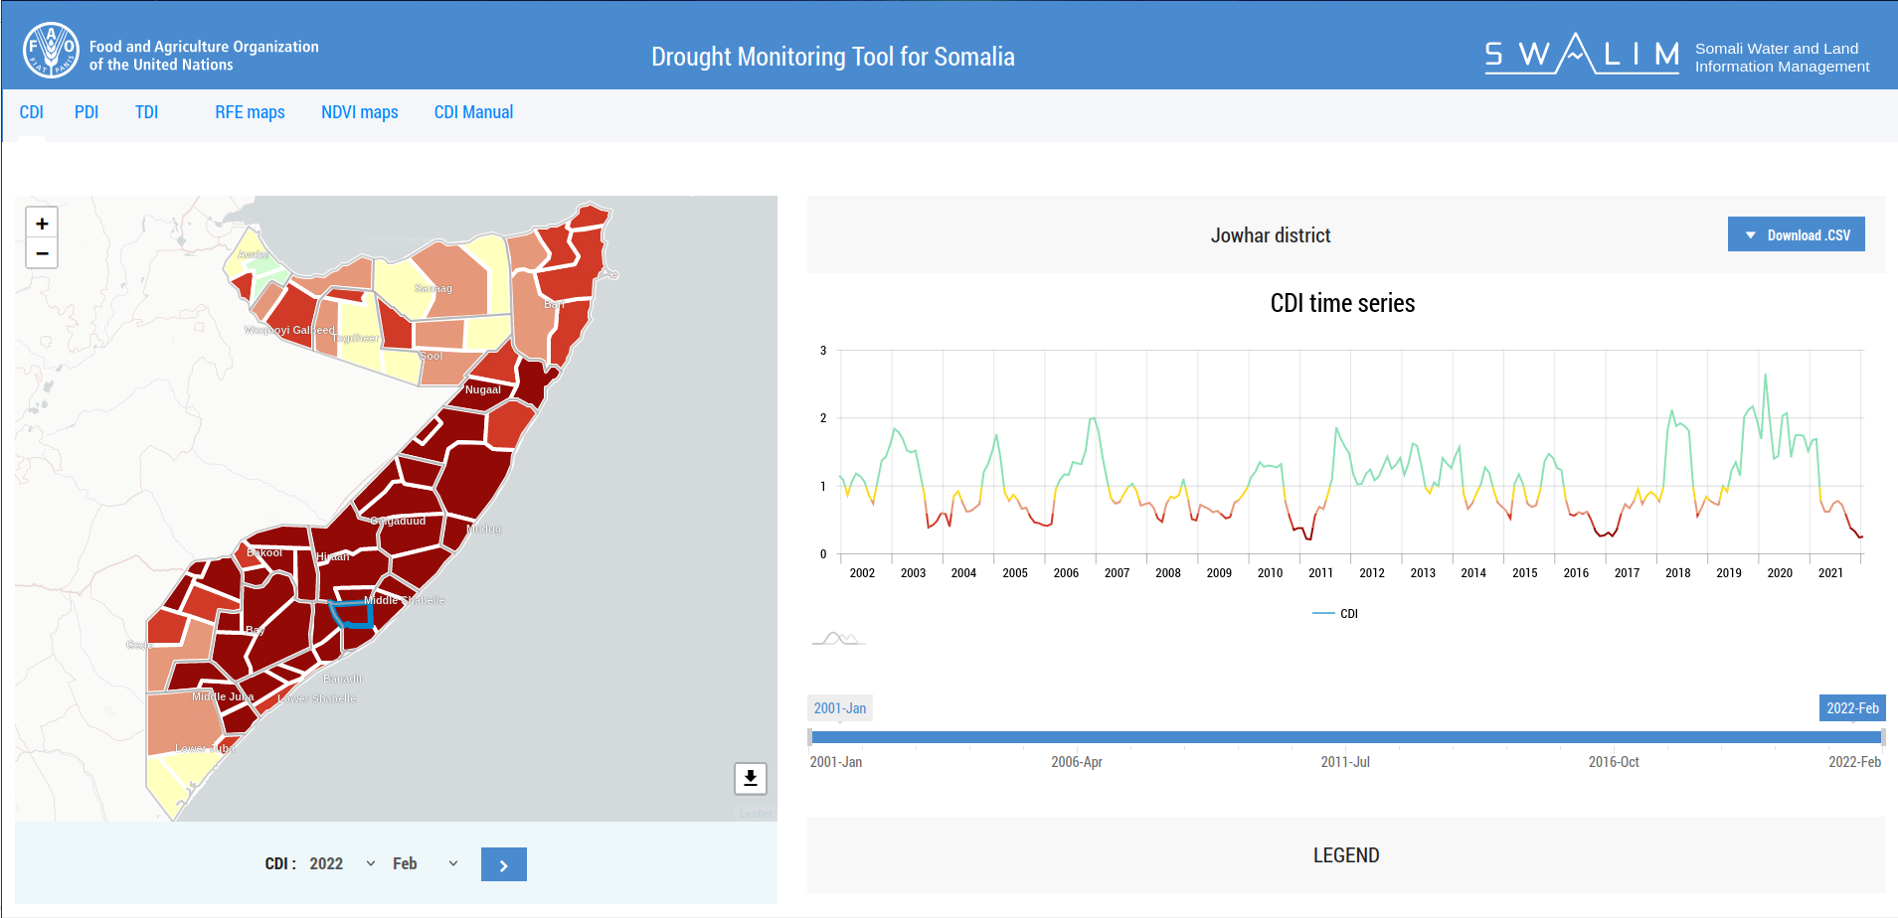**Description:** The CDI monitoring tool explores the use of three climatic conditions that influence drought conditions. This includes rainfall, temperature and the Normalised Vegetation Drought Index (NVDI) which is a proxy of soil moisture. The NDVI is a dimensionless index that describes the difference between visible and near-infrared reflectance of vegetation cover and can be used to estimate the density of greenness on an area of land.

**Responsibilities:** Primary Developer

**Skills:** Php, Vue, Boostrap4, Leaflet, Amcharts, QGIS, ArcGIS Pro and MySQL

**Domain: https://cdi.faoswalim.org**

* **Somali Climate TimeSeries Data (2020): FAO Somalia**

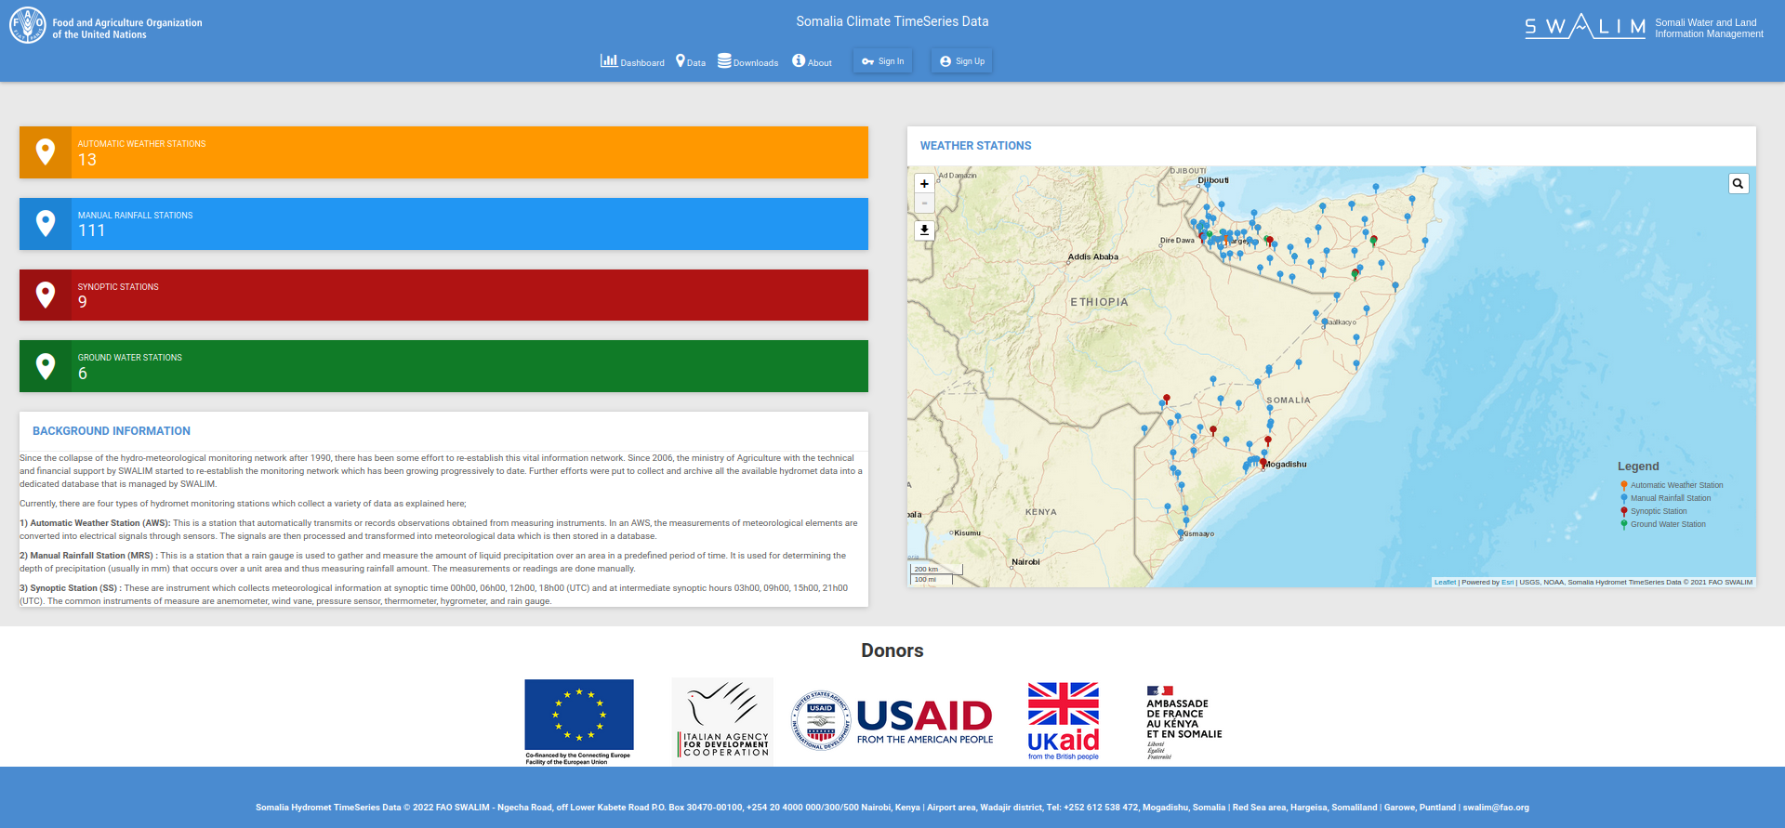**Description:** A web application tool for visualizing historical and near-realtime weather information from Automatic Weather Stations, Synoptic Stations, Ground Water Stations and Manual Stations.

**Responsibilities:** Primary Developer

**Skills:** Python, Django, Boostrap4, Leaflet, Highcharts, REST API, MsSQL, Windows Server, Ubuntu Server, IoT sensors and PostgreSQL- PostGIS

**Domain: https://climseries.faoswalim.org**

* **Somali National River Flow Archive (2020): FAO Somalia**

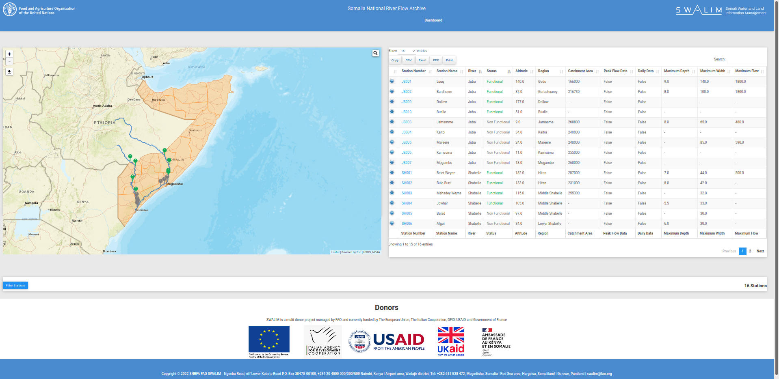**Description:** A web application tool for visualizing historical and daily river levels and flows.

**Responsibilities:** Primary Developer

**Skills:** Python, Boostrap4, Leaflet, Highcharts, ODK, REST API and PostgreSQL- PostGIS

**Domain: https://snrfa.faoswalim.org**

* **Somali Water Sources Information Management System (2019): FAO Somalia**

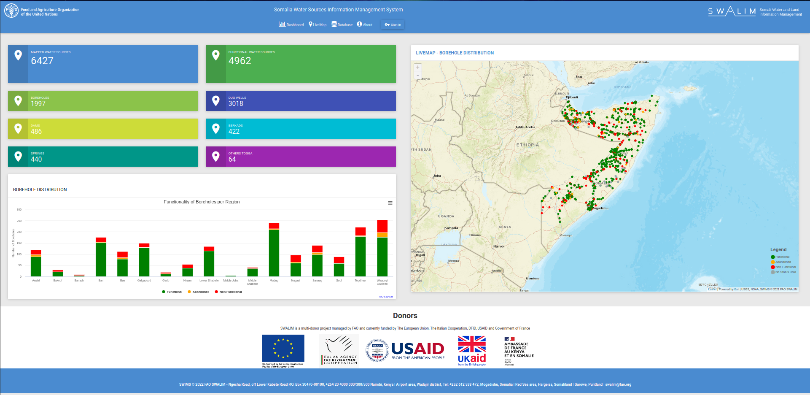**Description:** A platform to visualize number and types of water sources across administrative boundaries of Somalia as well as to manage, filter and map the water sources collected using mobile data app. The application also enables historical tracking of each water source.

**Responsibilities:** Primary Developer

**Skills:** Python, Boostrap4, Leaflet, Highcharts, ODK, ONA, QGIS and PostgreSQL- PostGIS

**Domain: https://swims.faoswalim.org**

**Spatial Data Infrastructures (SDIs)**

* **FAO SWALIM Geoportal (2019): FAO Somalia**

**D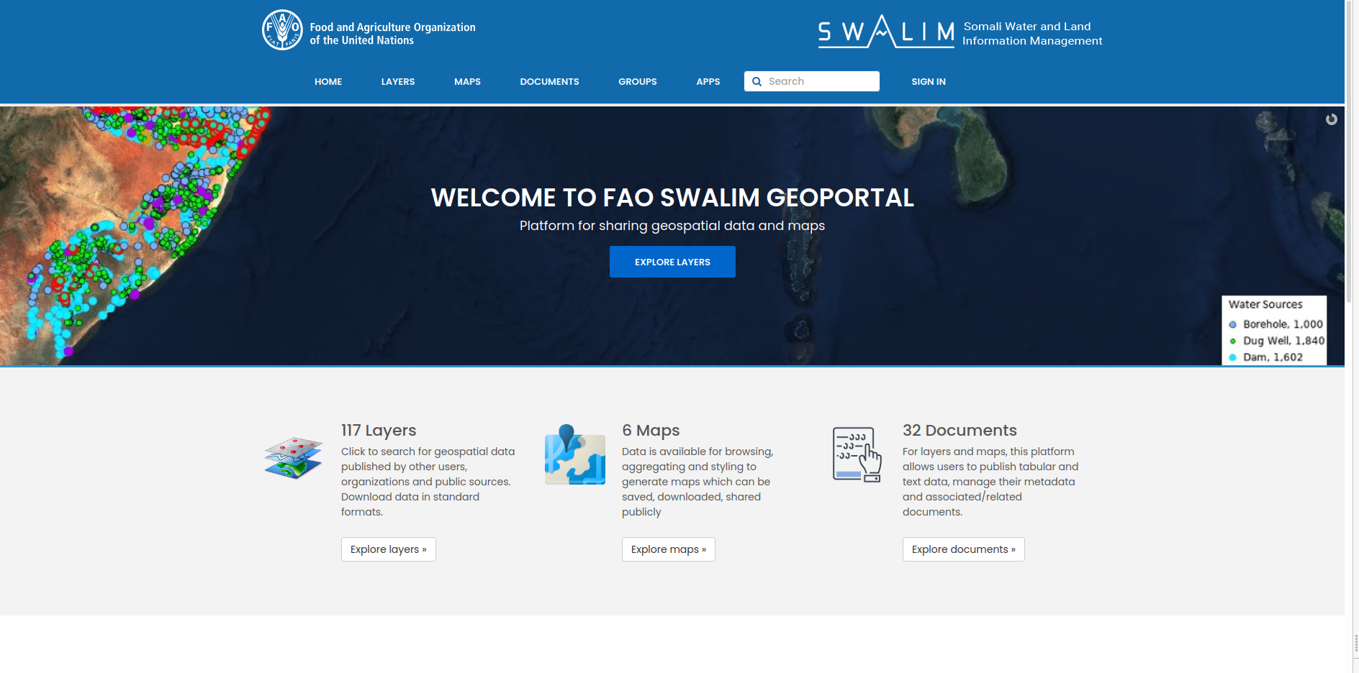escription:** A Spatial Data Infrastructure for FAO SWALIM to host all the spatial datasets and related documents.

**Responsibilities:** Maintenance, features development and security.

**Skills:** Python, GeoDjango, React, Bootrap4, jQuery, OpenLayers, GeoServer, REST APIs and PostGIS

**Domain:** [**https://spatial.faoswalim.org**](https://spatial.faoswalim.org/)

* **Biodiversity Atlas of Kenya (2018 – 2019): Upande, Kenya**

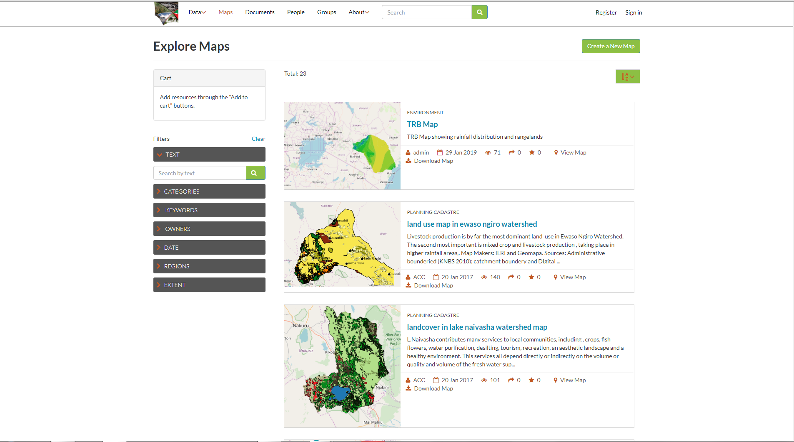

**Description:** An open access platform, hosting and supporting data generated from the Kenya’s Natural Capital- Biodiversity Atlas (2015). It gives access to other environmental socioeconomic and landcover change datasets, acquisition, storage, visualization, and analysis for a variety of uses while maintaining standards to facilitate data exchange and scalability for application in Kenya.

**Responsibilities:** Primary Developer **-** Design and development of the Spatial Data Infrastructure for the Biodiversity Atlas. Cartography and data standardization.

**Skills:** Python, GeoNode, ArcGIS Pro, uDig, QGIS, GeoServer, Leaflet, RESTful API and PostgreSQL- PostGIS.

* **Water Sector Trust Fund Portal (2018 – 2019): Upande, Kenya**

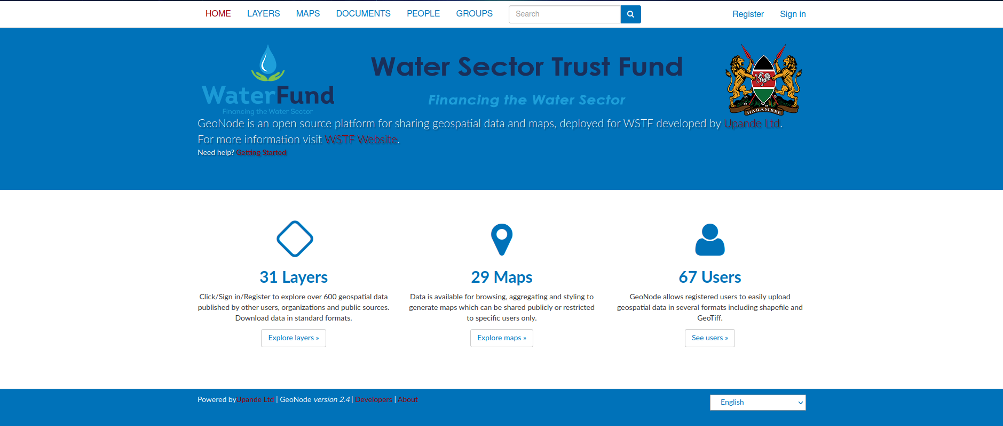

**Description:** WSTF Portal is a custom WaSHMIS GIS implemented for the Water Sector Trust Fund to facilitate management and visualization of spatial data streams in near real time of the Water utilities or mobile data collection activities under the Joint 6 Programme across 6 counties, 32 Water utilities in Kenya.

**Responsibilities:** Primary Developer **-** Design and development of the Spatial Data Infrastructure to host WSTF data from mobile data collection and Water Utilities. Standardization of data attributes, icons and visualization of the spatial datasets of all water utilities. Training on the management of the SDI platform. Management of the hosting servers and security.

**Skills:** Python, GeoNode, QGIS, GeoServer, Leaflet, RESTful API and PostgreSQL- PostGIS

* **WaSHMIS GIS (2016 – 2018): Upande, Kenya**

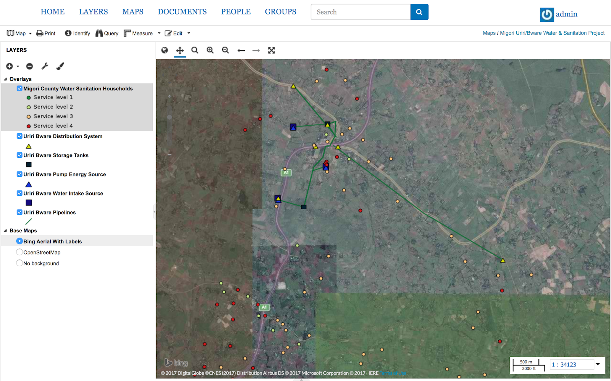**Description:** WaSHMIS GIS is a web portal to facilitate management and visualization of spatial data streams in near real time of the Water utilities or mobile data collection activities.

**Responsibilities:** Primary Developer - Design and development of the Spatial Data Infrastructure to host WaSHMIS data from mobile data collection and Water Service Providers. Standardization of data attributes, icons and visualization of the spatial datasets of all water utilities. Training on the management of the SDI platform. Management of the hosting servers and security.**Skills:** Python, GeoNode, QGIS, GeoServer, Leaflet, RESTful API and PostgreSQL- PostGIS

**DashboardsS**

* **Sensors Uptime (2022): FAO Somalia**

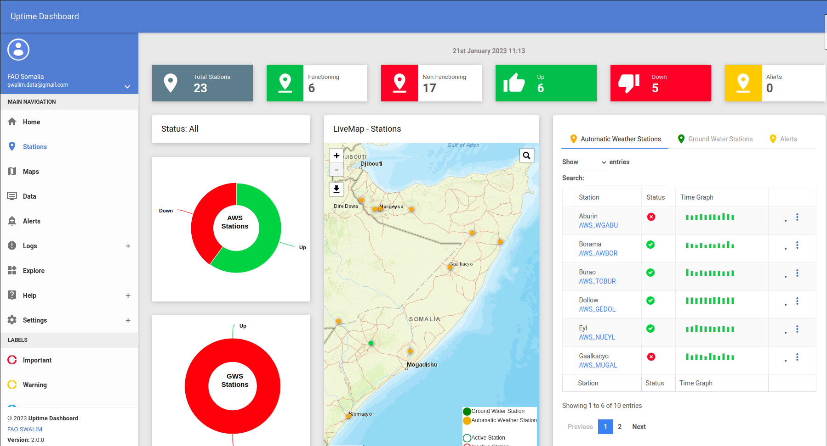**Description:** A dashboard to monitor and visualize near-realtime weather information from Automatic Weather Stations and Ground Water Stations.

**Responsibilities:** Primary Developer

**Skills:** Python, Django, Boostrap4, Leaflet, Highcharts, REST API, MsSQL, Windows Server, Ubuntu Server, IoT sensors and PostgreSQL- PostGIS

**Domain: https://climseries.faoswalim.org/uptime/**

* **4W Dashboard and River Breakages Dashboard (2021): FAO Somalia**

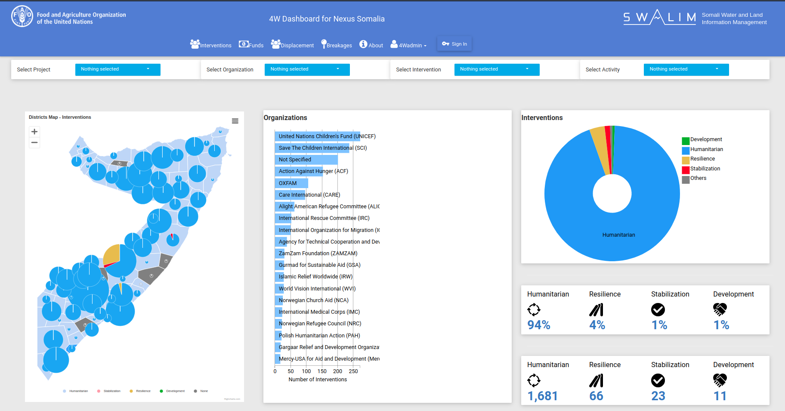**Description:** A 4W Dashboard to visualize UN multi-agency and partners’ project activities and status across Somalia. The River Breakage Dashboard shows the years there were river breakages and floods.

**Responsibilities:** Primary Developer

**Skills:** Python, D3, Crossfilter, Leaflet, RESTful API and PostgreSQL- PostGIS

* **WaSHMIS Dashboard (2016 – 2018): Upande, Kenya**

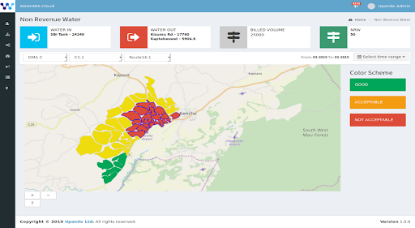

1. **Description:** Platform that enables WSPs data in the cloud or on utility’s infrastructure to be accessed, tracked, updated, and managed through a browser or desktop GIS.
2. **Responsibilities:** Integration of the dashboard with maps and statistics.
3. **Skills:** Python, D3, Crossfilter, Leaflet, RESTful API and PostgreSQL- PostGIS
4. **SAMPLE OF PROJECTS**

* **TelelBirds (2020): TelelBirds, Kenya**

**Landing Page**

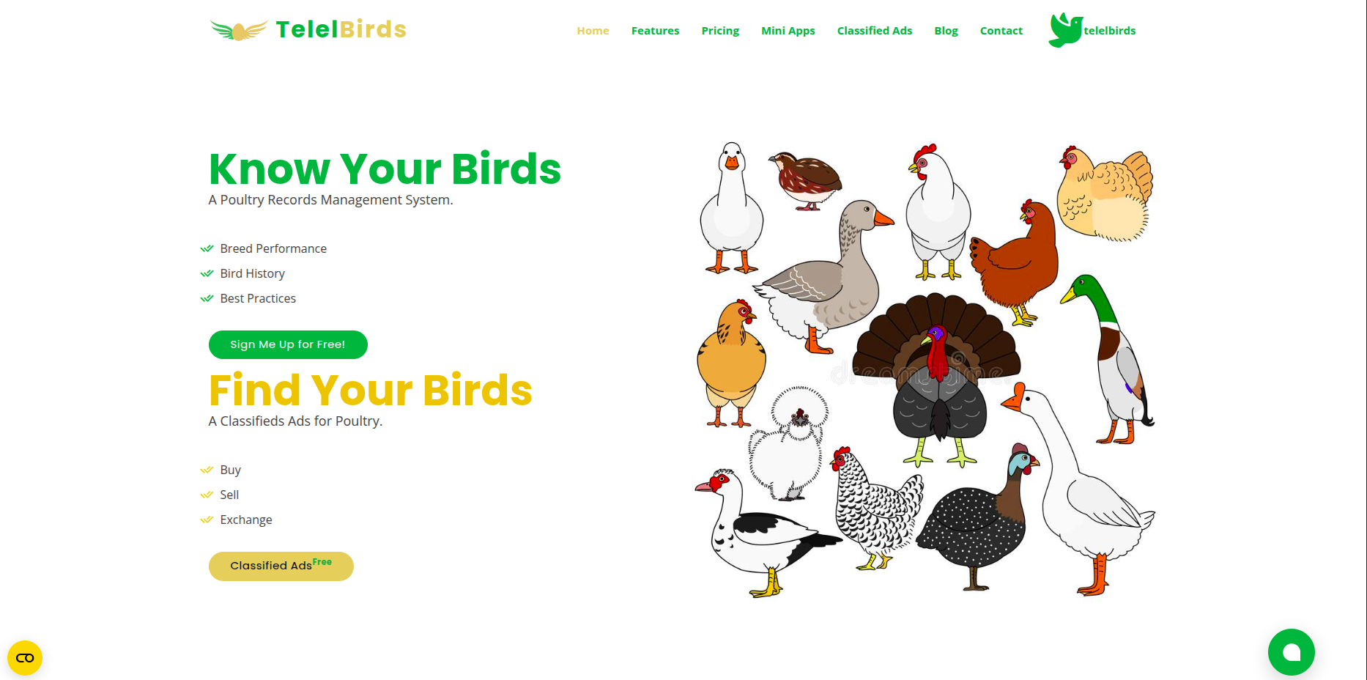

**Dashboard Overview**

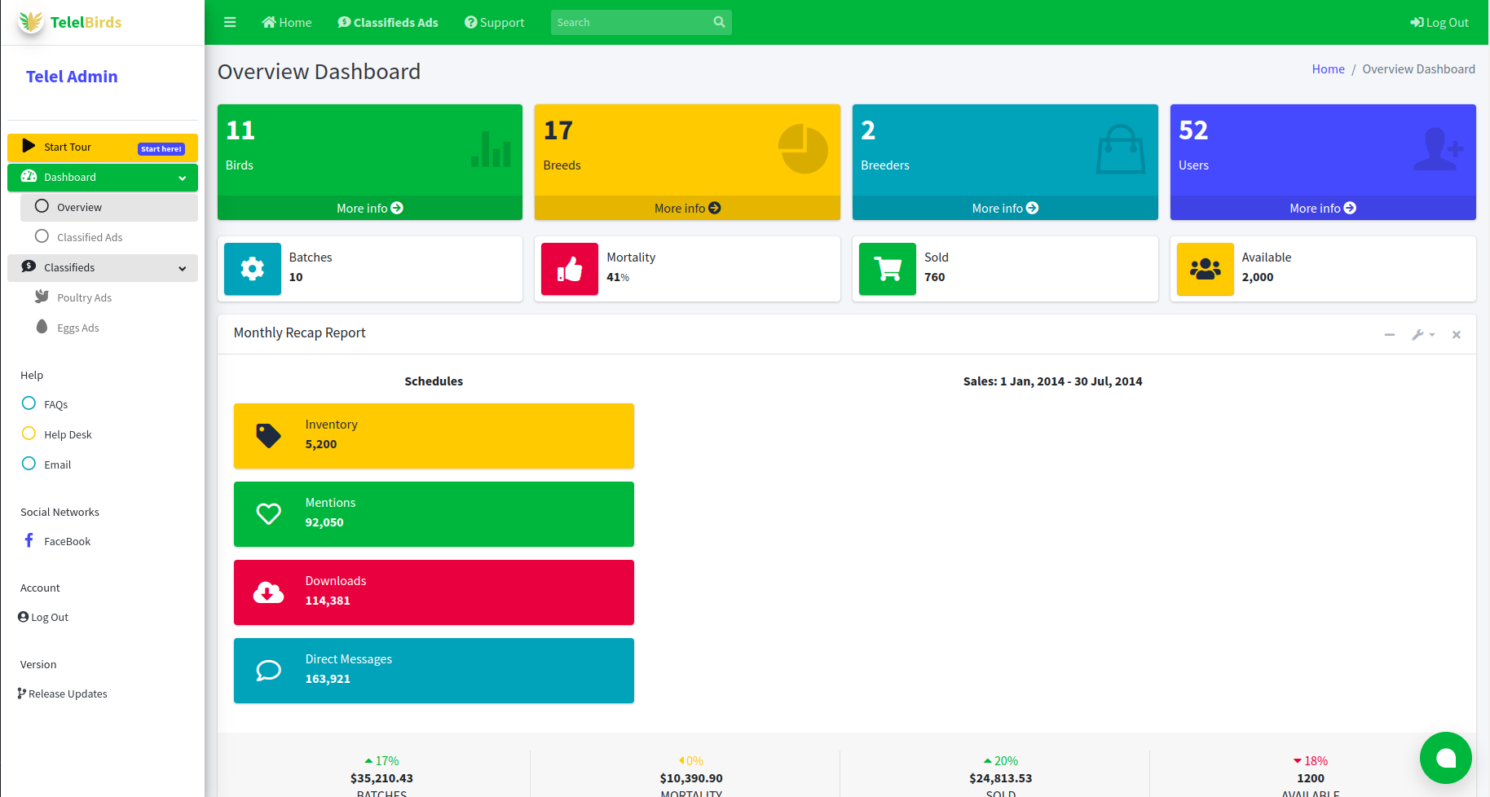**Description:** An online Enterprise Resource Planning (ERP) solution for breeders in commercial poultry farmers and small scale poultry keepers.

**Responsibilities:** Product Owner and Primary Developer

**Skills:** Python, D3, Crossfilter, Highcharts, RESTful API and PostgreSQL- PostGIS

**Domain: https://www.telelbirds.com**

**Domain:** **https://www.telelbirds.com/ads/**

* **GIS for Realtors (2019): Kenya**

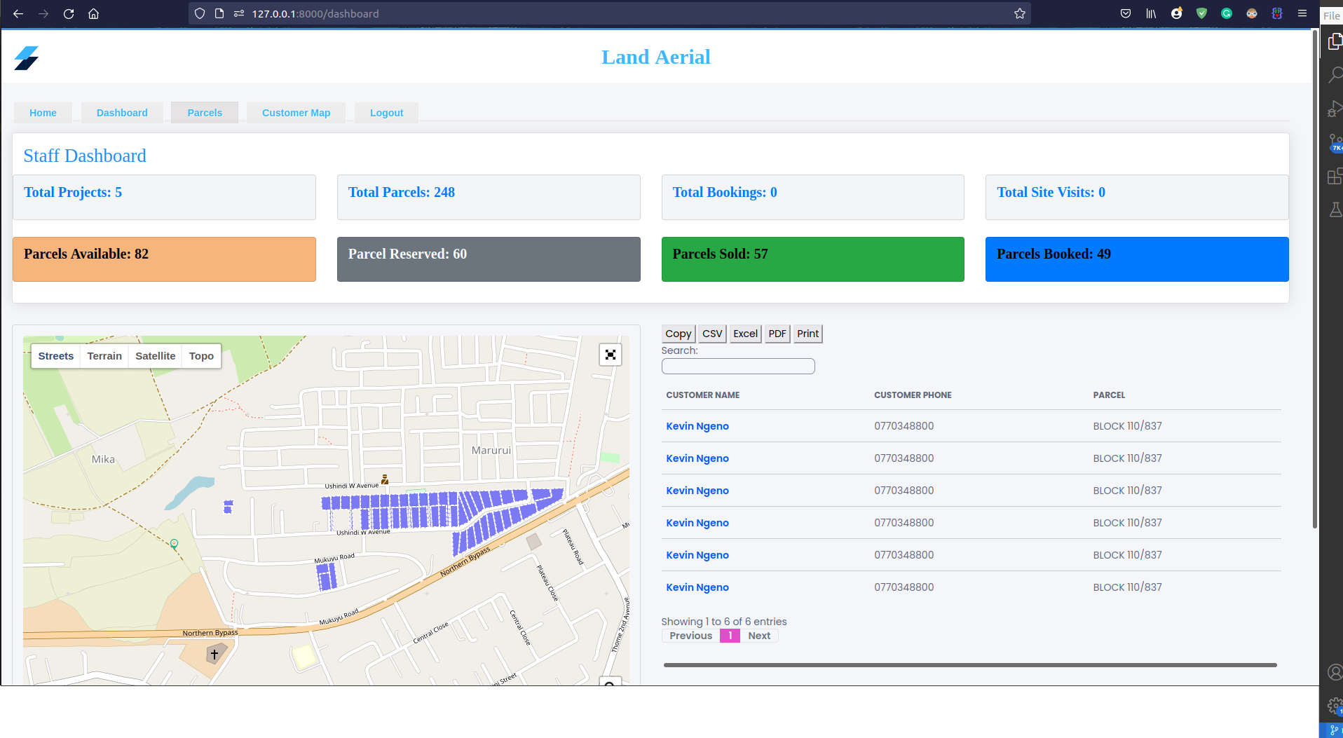**Dashboard**

**WebMap**

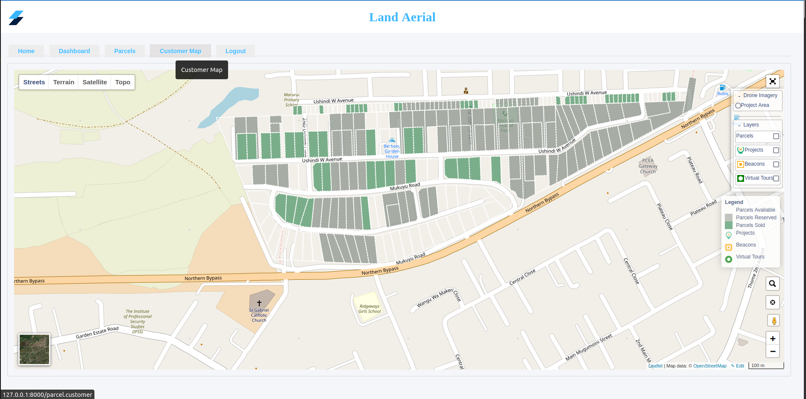

**Parcel Search**

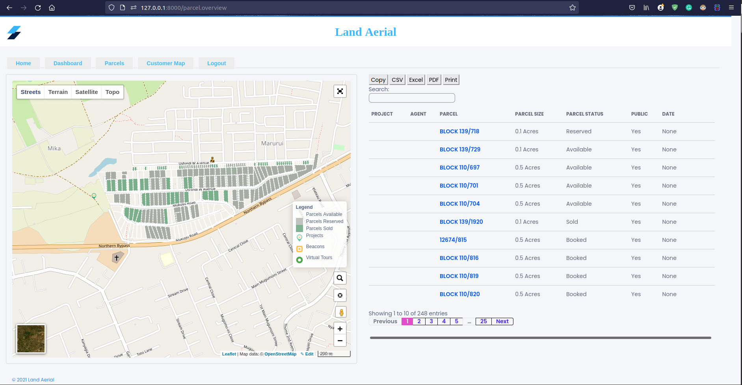

**Description:** A realtors prototype app using GIS.

**Responsibilities:** Product Owner and Primary Developer

**Skills:** Python, GeoDjango, Leaflet, QGIS, RESTful API and PostgreSQL- PostGIS